Mostarya’s Maid Café

1. Introduction

* Briefly describe the key features of your project.

2. Design and Implementation

Give a detailed description of the design and implementation of your project.

This section should contain:

* Details of how you converted from design to the actual realization of your project in terms of implementing the code.
* Any choices that you made, and any modifications that you made to the design, in response to difficulties that you might have encountered while implementing the project.
* A brief discussion of various components that you used in implementing your project, and the reasons you chose them over alternatives.
* Menu
  + For the Menu page, I wanted to incorporate a picture for each item in a fun way. I utilized card decks to achieve the spacing desired. To combat the alignment of the text, I had to adjust the image sizing since the responsive design I highly sought for countered all my attempts at making them uniform.
  + During my initial though process, I wanted to use a carousel to show the menu items. After considering when a customer is trying to pick something to eat that flipping back and forth the choices is not ideal. With that in mind, I decided the card deck would be the better option.

* About
  + During the initial thought process, all the information was going to be on the page without any modals. After seeing the design that had an odd orientation, I decided that a modal button displaying the rules would be cleaner and more interactive. Since modals interact with the main page by blacking it out, I used it as an emphasis for the content itself. This way, the rules will be clearly seen by those who notice the button, but it’s not impacting the atmosphere of the main content.

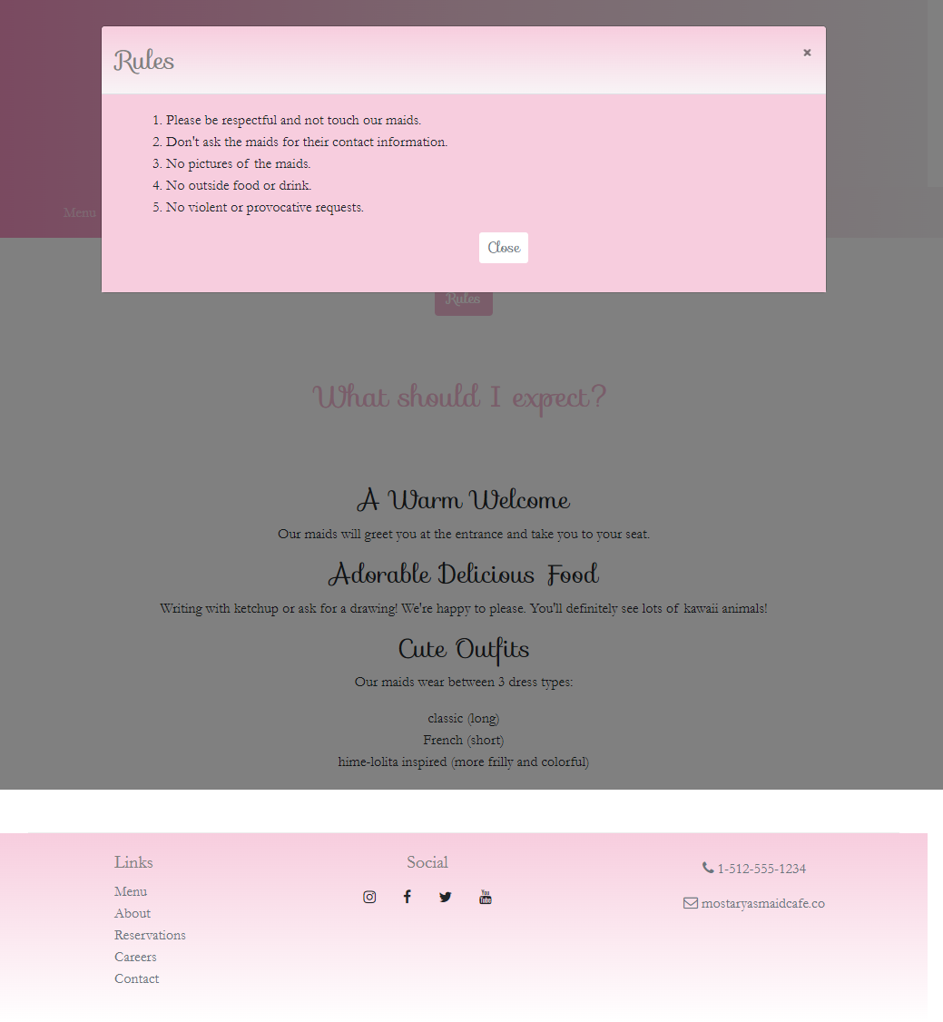

* Reservations
  + I wanted to have an interactive form so I used the card deck again to show the dresses that can be used for the user’s event theme and tied them to activate their respective radio button as well as their label.
  + I would’ve liked the card decks to be responsive and have a scroll bar at XS viewports, but I found no way to get both the card deck look and scrollbar since card decks do not have responsive functionality.

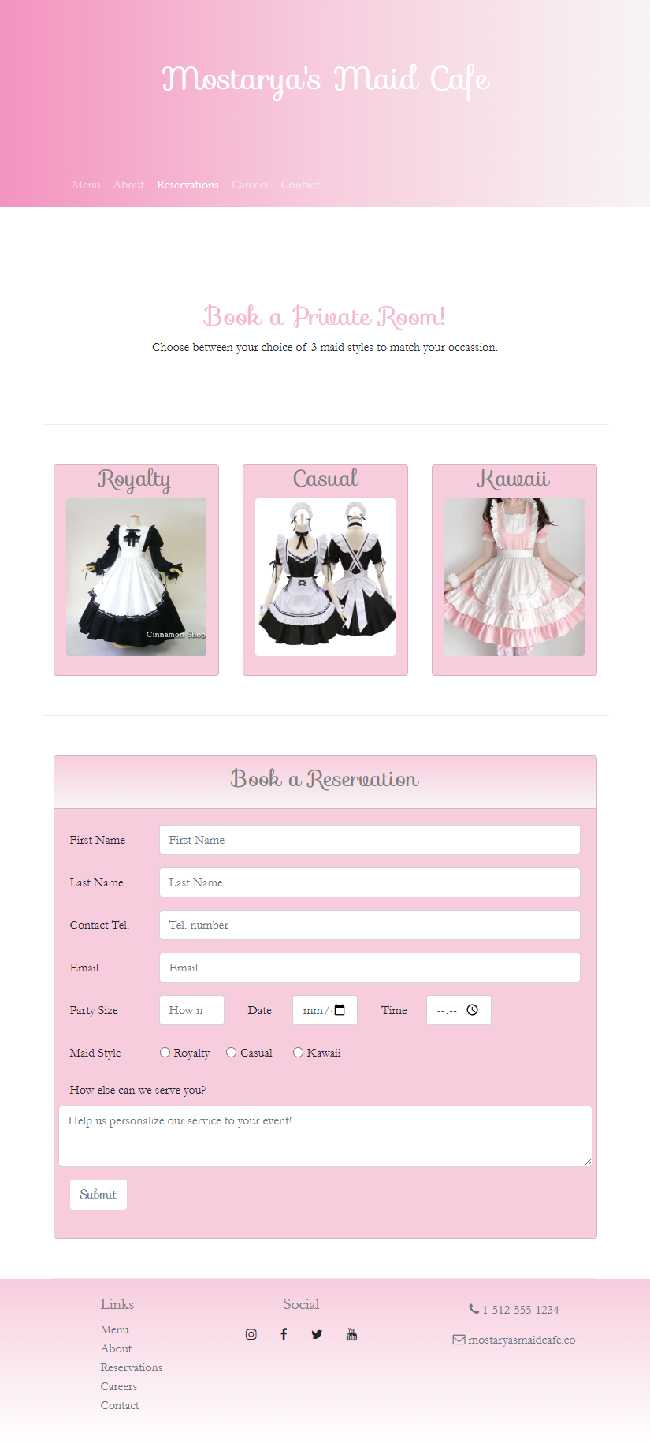

* Careers
  + I wanted to put in a simple application form on the website. Since this maid café has only a few necessary jobs, I decided to use a dropdown selector for the position. The biggest challenge was figuring out how to style the default “Choose File” button.

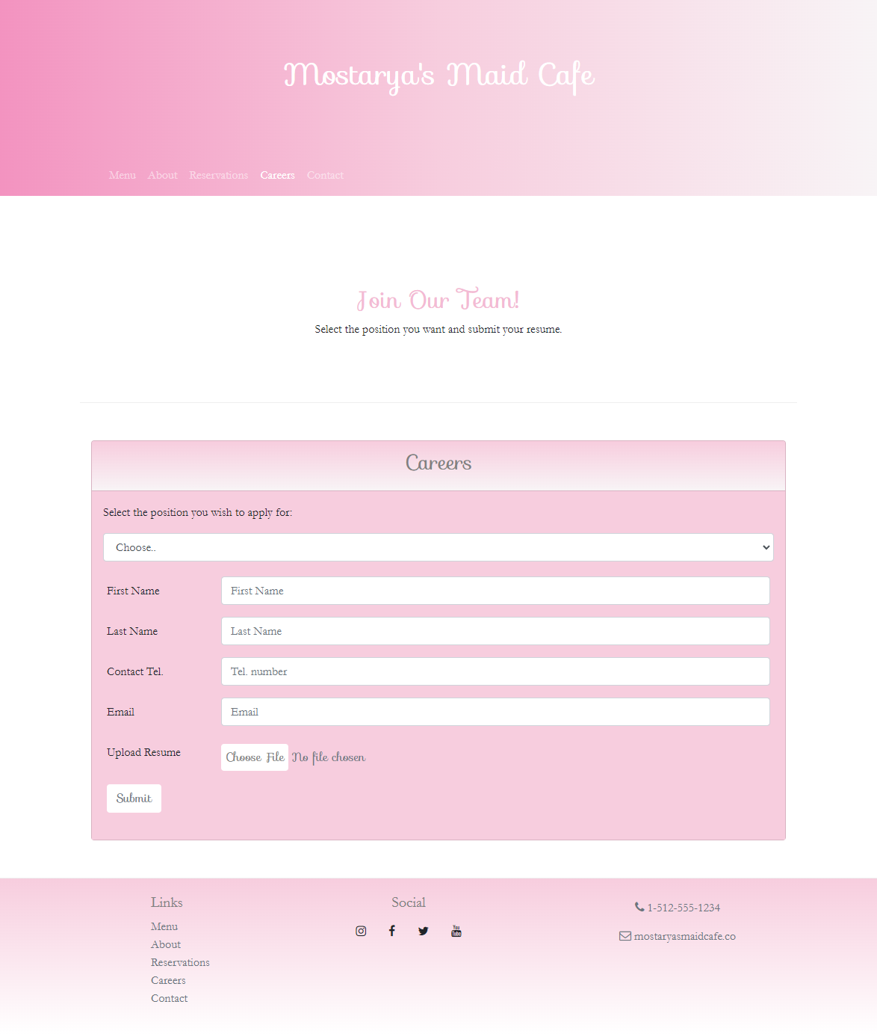

3. Conclusions

* Discuss what you personally learned from your project.
  + To style the Career page’s file input button, I needed to use the **.custom-file** class and the CSS selector 🡪 **.custom-file::-webkit-file-upload-button**
  + Sass makes styling so much easier to read!
* Discuss the best features and the shortcomings of the project.
  + Best features
    - Rules modal
    - Card decks
  + Shortcomings
    - There wasn’t a good use implement breadcrumbs.
    - Not many chances to implement JavaScript.
* Discuss any choices that you might have made differently, in hindsight after completing the project.
  + I would have loved to make it so that each job linked to a separate description page. I figured when I have more time and knowledge with other languages, I could practice having other job page formats.